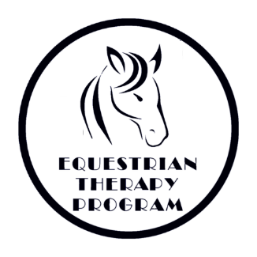
Equine University
Rider Information and Health History

Student Name: _________________________________________________________
Parent/Guardian: ________________________________________________________
Address: __________________________________________ City:_______________________
State: ___________ Zip Code: ___________ Email:___________________________________
Phone: _________________________________ Cell:__________________________________
Parent/Guardian address (if different from above): ___________________________________________________________________________
Caregiver: _________________________ Phone: ________________________________
Please contact named individual in the event of a cancellation if different from student’s phone number. Name: ______________________ Phone: ___________________________

Gender: M F DOB: ______________ Weight: ___________ Height: ____________
Allergies and Medications: _______________________________________________________________________________________________________________________________________________________________________________________________________________________________________
Other Health Conditions: ________________________________________________________
___________________________________________________________________________________________________________________________________________________________________________________________________________________________________________________________________________________________________________________

Revised 3/30/2024
22532 Bowsher Road · Cridersville, Ohio 45806 · Phone (419) 657-2700 · Fax (419) 657-2887
(Page 1 of 6)

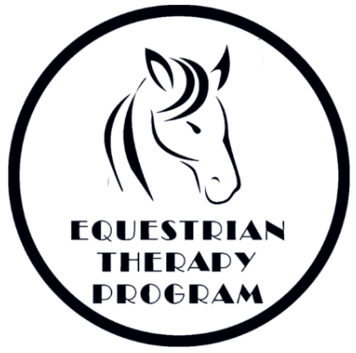

Emergency Medical Consent Form

Students Name: _______________________________________________________________

Parent(s)/Legal Guardian(s): _________________________________________________________________

Physician’s Name: _____________________________________________ Phone: _____________________

Address: _____________________________ City: ___________________ State: ______ Zip: _____________

Preferred Medical Facility: _________________________

Health Insurance Co. ____________________________________ Policy # __________________________

Person who is authorized to give temporary assistance or care in the absence of parent or guardian:

Name: ___________________________________ Phone: __________________ Relation: ______________

Revised 3/30/2024
22532 Bowsher Road · Cridersville, Ohio 45806 · Phone (419) 657-2700 · Fax (419) 657-2887
(Page 2 of 6)
Consent
In case of medical emergency, the undersigned authorizes Equestrian Therapy Program to provide such medical assistance as they determine to be necessary,
I hereby give my consent, in the event that all reasonable attempts to contact me have been unsuccessful, to the administration of any treatment deemed necessary by or the transfer to the student to ________________
(preferred hospital) or any hospital reasonably accessible. This authorization does not cover major surgery unless the medical opinions of two other licensed physicians or dentists concur in the necessity to such surgery and are obtained prior to the performance of such surgery.

Date: ___________ Consent Signature: _______________________________________________________
(Participant or legal guardian)

Non Consent
I do not give my consent for emergency medical treatment/aid in the case of illness or injury during the process of receiving services or while being on the property or The Equestrian Therapy Program.
__ Parent or Legal Guardian will remain on site at all times during equine assisted activities.
__ In the event emergency treatment/aid is required, I wish the following procedure to take place.

_____________________________________________________________________________

Date: ___________ Non-Consent Signature: ____________________________________________________
(Participant or legal guardian)

Participants under age (18) must have this form signed by a legal guardian

Revised 3/30/2024
22532 Bowsher Road · Cridersville, Ohio 45806 · Phone (419) 657-2700 · Fax (419) 657-2887
(Page 3 of 6)
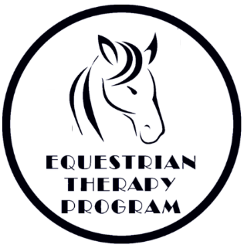

Photo Release Form

I _______________________ give permission for the Equestrian Therapy Program to take still and moving photographs and films, including television pictures, of our son/daughter/ward/self _________________________________________________.
In addition, I consent and authorize the ETP and its advertising agencies, the news media, and any other person or organization interested in the ETP and its work to use and reproduce said photographs, films and pictures, and to circulate and publicize the same by any and all means, including, but not limited to, news-papers, magazines, television, brochures, pamphlets, instructional materials, books, and clinical material.
No inducements or promises have been made to us/me to secure our/my signature(s) to this release other than the intention of the ETP to use said photographs, films and pictures for the primary purpose of promoting and aiding the ETP and its work. The ETP is a nonprofit Ohio corporation.
Date: ___________________
_____________________________ __________________________________
Signature of Witness Signature of Parent(s)/ Guardian
_____________________________ ___________________________________
Signature of Witness Signature of Participant (if over 18)
If you do consent to the above, then this form needs to be signed by the participant, if over age 18, and either by both natural parents, or by the sole parent having legal custody, or by the participant’s legal guardian.
_________________________________________________________________________________________
No Photo
I ___________________________________ do not consent to photos or moving pictures of son/daughter/ward/self.
Date: _____________________
_____________________________ __________________________________
Signature of Witness Signature of Parent(s)/ Guardian
_____________________________ ___________________________________
Signature of Witness Signature of Participant (if over 18)

Revised 3/30/2024
22532 Bowsher Road · Cridersville, Ohio 45806 · Phone (419) 657-2700 · Fax (419) 657-2887
(Page 4 of 6)
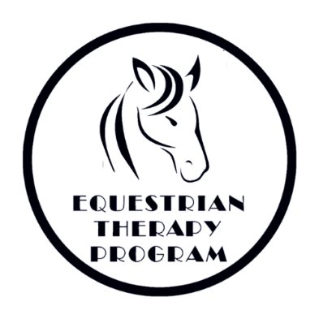

Student Guidelines

- The student must be FOUR years of age and have a minimum sitting balance and head control of a 6-month-old. Students who have had a Gran Mal seizure within the last year may not be eligible for horseback riding.
- Our weight limit for riding is determined by assessment and available equine.
- ALL FORMS MUST BE FILLED OUT, SIGNED and returned to us before the student may ride. No student will be permitted to ride without these forms.
- When riding, the student must be in long pants and a sturdy shoe, preferably with heels. SANDALS ARE NOT PERMITTED due to the possibility of foot injuries. Approved helmets are required and provided. Please remember to wear hair styles that are conducive to a snug-fitting hard hat. Avoid dangling earrings and other jewelry.
- Please observe all barn rules while at the farm. All family and visitors should stay inside the bleacher/lounge area of the barn unless specifically invited to go to another part of the building.
- Our volunteers give of their time and talent so that you are able to ride. PLEASE let us know AS SOON AS POSSIBLE if you will be unable to attend a class so that we can schedule our volunteers accordingly. We can be reached at 419-657-2700. For cancellations less than 24 hours in advance, please call the office and leave a message if we do not pick up.
- During extreme weather, not conducive to riding, we will provide alternative activities. In the event that travel is not advisable we will cancel classes, see WLIO for cancellations or call the office. We will call you at the numbers you have provided on your forms.
- If a student has TWO UNEXCUSED ABSENCES in a session, we have the right to excuse them from the program. We have a waiting list of students who would like to ride and we value the time our volunteers donate.
- If we determine that this type of riding therapy is not suitable for a student because of safety to the student, volunteer, instructor, horse, or for any other reason, we reserve the right to deny riding to that student.

Thank You for Your Cooperation,
The Equestrian Therapy Program Staff

Revised 3/30/2024
22532 Bowsher Road · Cridersville, Ohio 45806 · Phone (419) 657-2700 · Fax (419) 657-2887
(Page 5 of 6)

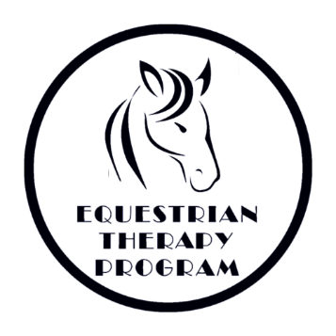

Barn Rules

- Riders must wear a helmet when mounted and working with a horse.
- No chewing gum while mounted.
- Everyone is to walk quietly through the barn, without running.
- Always walk around the head of the horse, not behind.
- Respect all persons, animals and property.
- Students (adults and youths) must always stay with an instructor, volunteer, or teacher when going beyond waiting area.
- Treats can only be fed to the horses with instructor permission and with the help of a volunteer. No feeding from your hand only use treat bowls.
- Students must wear long trousers that fit neatly and sturdy closed-toed shoes.
- Indoor voices and appropriate language must be used at all times.
- Pet the horses on the neck or shoulder – not the face. Approach them in a slow quiet manner.
- Listen to the instructor and follow directions carefully.
- Staff, volunteers, and participants will silence their cell phones during equine assisted activities and/or while handling equines. Under no circumstances will staff, volunteers, or participants answer their cell phones during equine assisted activities or while handling equines.

Revised 3/30/2024
22532 Bowsher Road · Cridersville, Ohio 45806 · Phone (419) 657-2700 · Fax (419) 657-2887
(Page 6 of 6)

